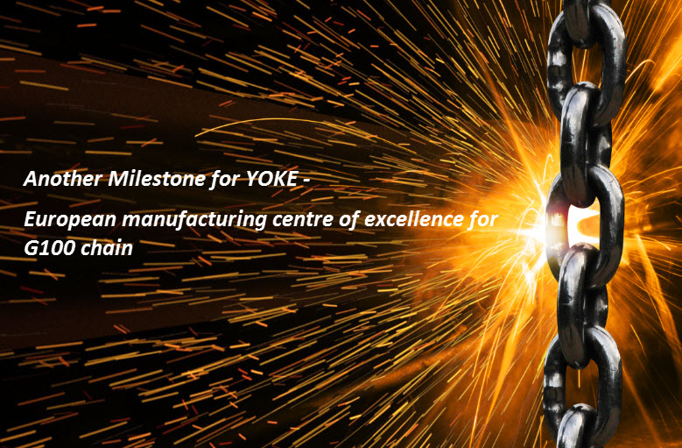
YOKE Industrial Corporation is excited to announce a strategic partnership with HKF, Germany. This partnership brings with it a long and proud history of manufacturing various grades of alloy, carbon and stainless steel chain and as with the strategy of YOKE, continuous investment in modern and efficient chain machinery.
HKF are 3rd generation manufacturer of lifting and mooring chain based near Dortumd, Germany. They also have third party approvals including the DGUV H stamp for lifting chain. HKF will be an exclusive partner of YOKE in the manufacture of G100 lifting chain.
YOKE CHAIN, manufactured by HKF will have its own unique markings and identification, and will be marketed as YOKE Extreme lifting chain – manufactured in Germany.
We will have the capability to have YOKE G100 lifting chain available from our Taiwan HQ and also from the chain plant in Germany to ensure we can service all our partners throughout the world.

